# ReactJS.Net

<https://reactjs.net/tutorials/aspnet4.html>

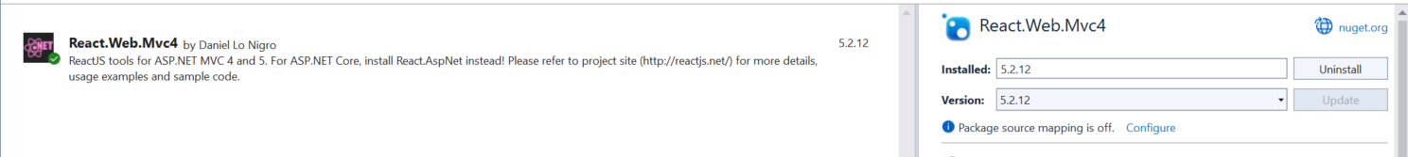



Instead of JavaScriptEngineSwitcher.V8.Native.win-x64, install



For the index file where you are including ReactJS

<main>

<div id="content"></div>

<script crossorigin src="https://cdnjs.cloudflare.com/ajax/libs/react/16.13.0/umd/react.development.js"></script>

<script crossorigin src="https://cdnjs.cloudflare.com/ajax/libs/react-dom/16.13.0/umd/react-dom.development.js"></script>

<script src="https://cdnjs.cloudflare.com/ajax/libs/remarkable/1.7.1/remarkable.min.js"></script>

<script src="@Url.Content("~/Scripts/Tutorial.jsx")"></script>

</main>